**LIT TRAINING**

**Batch Name : SAP ABAP -25                                                            DAY 6 ASSIGNMENT**

**EMPLOYEE ID – 46247689**

**1. Create a program to Upload the data in Application Server (AL11). Use any table join Based on your preference. Update it in /tmp folder.**

**=======================DATA=======================**

**material1 1 ROH SHORTDESC KM 01**

**material2 1 ROH SHORTDESC KM 01**

**material3 1 ROH SHORTDESC KM 01**

**material4 1 ROH SHORTDESC KM 01**

**==================================================**

**REPORT TO UPLOAD DATA FROM DESKTOP TO SERVER**

*\*&---------------------------------------------------------------------\**  
*\*& Report ZYNY_ABHAY_REPORT19*  
*\*&---------------------------------------------------------------------\**  
REPORT ZYNY_ABHAY_REPORT19.  
  
*\*----------------------------------------------------------------------\**  
*\*     Type Decalaration*  
*\*----------------------------------------------------------------------\**  
TYPES: BEGIN OF TY_MARA,  
         MATNR TYPE MATNR, *" Material Number*  
         MBRSH TYPE MBRSH, *" Industry sector*  
         MTART TYPE MTART, *" Material TYPE*  
         MAKTX TYPE MAKTX, *" MATERIAL DESC*  
         MEINS TYPE MEINS, *" Base Unit of Measure*  
         MATKL TYPE MATKL, *" Material Group*  
       END OF TY_MARA.  
  
*\*----------------------------------------------------------------------\**  
*\*     Data Decalaration*  
*\*----------------------------------------------------------------------\**  
DATA : IT_MARA TYPE  TABLE OF TY_MARA,  
       WA_MARA TYPE TY_MARA,  
       LV_FILE TYPE STRING.  
  
DATA: gv_file   TYPE rlgrap-filename.

*\*----------------------------------------------------------------------\**  
*\*     START-OF-SELECTION*  
*\*----------------------------------------------------------------------\**  
START-OF-SELECTION.  
  LV_FILE = 'C:\Users\abhbhagw\OneDrive - Capgemini\Desktop\Materials7689.txt'. *" File Path*  
  
  CALL FUNCTION 'GUI_UPLOAD'  
    EXPORTING  
      FILENAME                = LV_FILE  
      FILETYPE                = 'ASC'  
      HAS_FIELD_SEPARATOR     = 'x'  
    TABLES  
      DATA_TAB                = IT_MARA  
    EXCEPTIONS  
      FILE_OPEN_ERROR         = 1  
      FILE_READ_ERROR         = 2  
      NO_BATCH                = 3  
      GUI_REFUSE_FILETRANSFER = 4  
      INVALID_TYPE            = 5  
      NO_AUTHORITY            = 6  
      UNKNOWN_ERROR           = 7  
      BAD_DATA_FORMAT         = 8  
      HEADER_NOT_ALLOWED      = 9  
      SEPARATOR_NOT_ALLOWED   = 10  
      HEADER_TOO_LONG         = 11  
      UNKNOWN_DP_ERROR        = 12  
      ACCESS_DENIED           = 13  
      DP_OUT_OF_MEMORY        = 14  
      DISK_FULL               = 15  
      DP_TIMEOUT              = 16  
      OTHERS                  = 17.  
  IF sy-subrc = 1.  
    MESSAGE E007(ZYNY_ABHAY_MESSAGE).  
  ELSEIF sy-subrc = 2.  
    MESSAGE E008(ZYNY_ABHAY_MESSAGE).  
  ELSEIF sy-subrc = 3.  
    MESSAGE E009(ZYNY_ABHAY_MESSAGE).  
  ELSEIF sy-subrc = 4.  
    MESSAGE E010(ZYNY_ABHAY_MESSAGE).  
  ELSEIF sy-subrc = 5.  
    MESSAGE E011(ZYNY_ABHAY_MESSAGE).  
  ELSEIF sy-subrc = 6.  
    MESSAGE E012(ZYNY_ABHAY_MESSAGE).  
  ELSEIF sy-subrc = 7.  
    MESSAGE E013(ZYNY_ABHAY_MESSAGE).  
  ELSEIF sy-subrc = 8.  
    MESSAGE E014(ZYNY_ABHAY_MESSAGE).  
  ELSEIF sy-subrc = 9.  
    MESSAGE E015(ZYNY_ABHAY_MESSAGE).  
  ELSEIF sy-subrc = 10.  
    MESSAGE E016(ZYNY_ABHAY_MESSAGE).  
  ELSEIF sy-subrc = 11.  
    MESSAGE E017(ZYNY_ABHAY_MESSAGE).  
  ELSEIF sy-subrc = 12.  
    MESSAGE E018(ZYNY_ABHAY_MESSAGE).  
  ELSEIF sy-subrc = 13.  
    MESSAGE E019(ZYNY_ABHAY_MESSAGE).  
  ELSEIF sy-subrc = 14.  
    MESSAGE E020(ZYNY_ABHAY_MESSAGE).  
  ELSEIF sy-subrc = 15.  
    MESSAGE E021(ZYNY_ABHAY_MESSAGE).  
  ELSEIF sy-subrc = 16.  
    MESSAGE E022(ZYNY_ABHAY_MESSAGE).  
  ELSEIF sy-subrc = 17.  
    MESSAGE E001(ZYNY_ABHAY_MESSAGE).  
  ENDIF.  
  
  WRITE : / 'DATA TO BE UPLOADED'.  
  ULINE.  
  LOOP AT IT_MARA INTO WA_MARA.  
    WRITE :/ WA_MARA-MATNR,  
              WA_MARA-MBRSH,  
              WA_MARA-MTART,  
              WA_MARA-MAKTX,  
              WA_MARA-MEINS,  
              WA_MARA-MATKL.  
    CLEAR WA_MARA.  
  
  ENDLOOP.  
  
  IF NOT IT_MARA[] IS INITIAL.  
    PERFORM save_file.  
  ELSE.  
    MESSAGE 'No data found' TYPE 'I'.  
  ENDIF.  
  
*\*&---------------------------------------------------------------------\**  
*\*&      Form  save_file*  
*\*&---------------------------------------------------------------------\**  
FORM save_file.  
  DATA: lv_data TYPE string.  
  
*\*Move complete path to filename*  
  gv_file = 'Materials7689.txt'.  
  
*\* Open the file in output mode*  
  OPEN DATASET gv_file FOR OUTPUT IN TEXT MODE ENCODING DEFAULT.  
*\*  OPEN DATASET gv_file FOR OUTPUT IN BINARY MODE.*  
  IF sy-subrc NE 0.  
    MESSAGE 'Unable to create file' TYPE 'I'.  
    EXIT.  
  ENDIF.  
  
  LOOP AT IT_MARA INTO WA_MARA.  
    CONCATENATE WA_MARA-MATNR  
                WA_MARA-MBRSH  
                WA_MARA-MTART  
                WA_MARA-MAKTX  
                WA_MARA-MEINS  
                WA_MARA-MATKL  
     INTO lv_data  
     SEPARATED BY ' '.  
  
*\*TRANSFER moves the above fields from workarea to file  with comma*  
*\*delimited format*  
    TRANSFER lv_data TO gv_file.  
    CLEAR: WA_MARA.  
  ENDLOOP.  
*\* close the file*  
  CLOSE DATASET gv_file.  
  
ENDFORM.                    *" save_file*

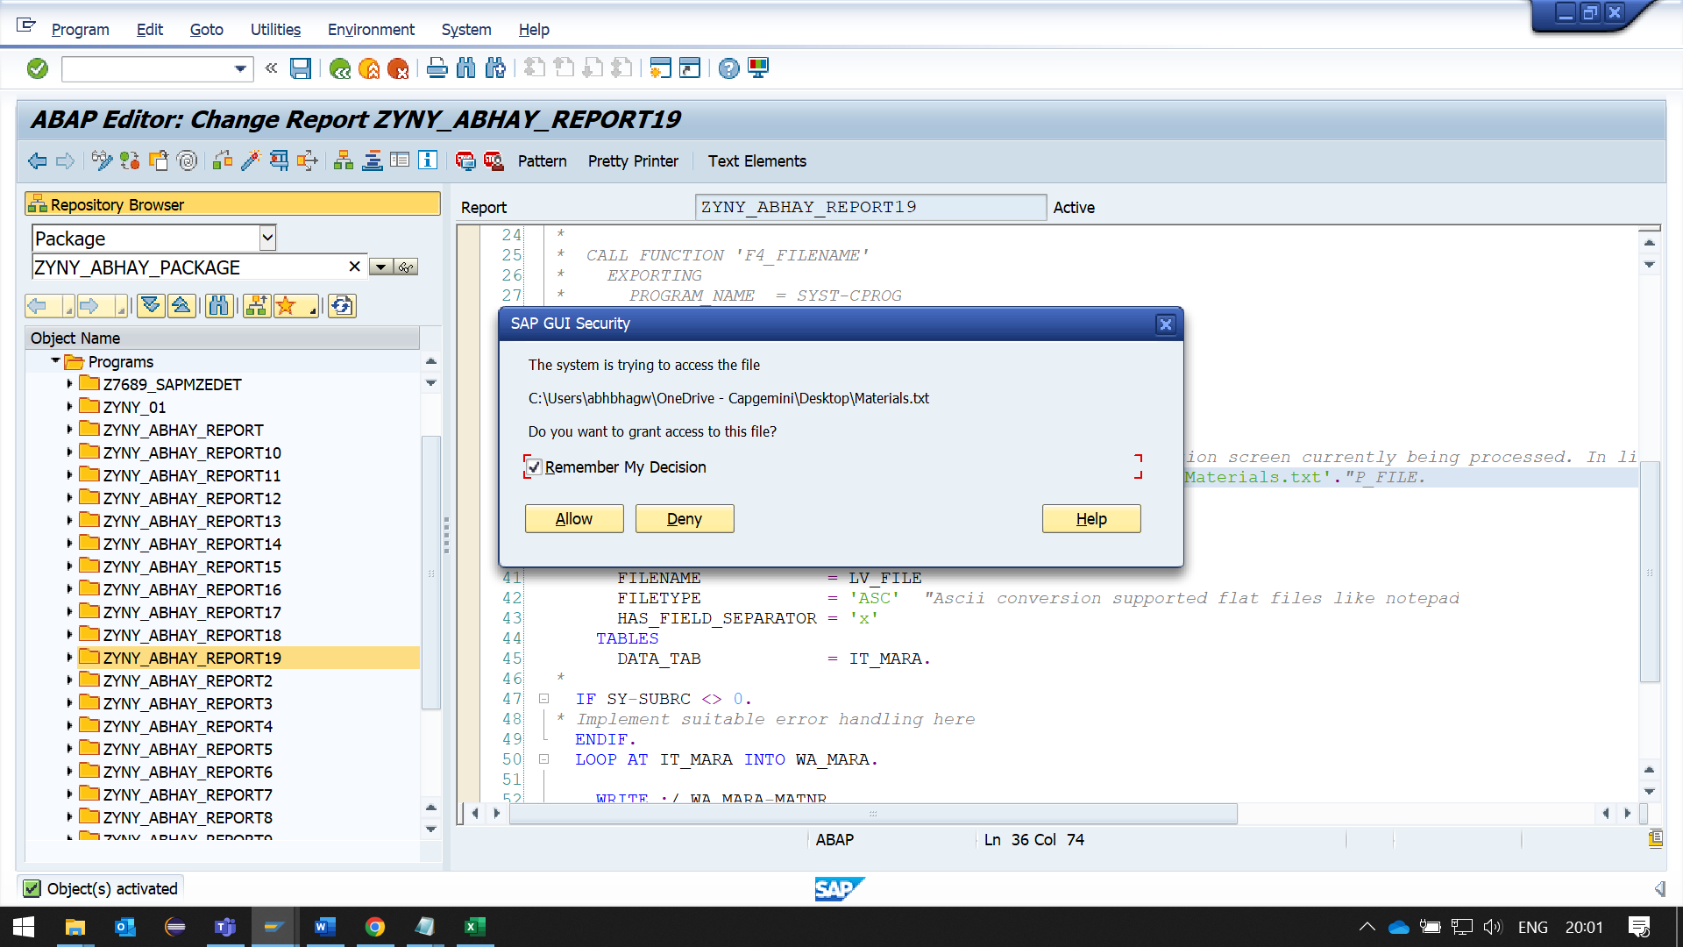

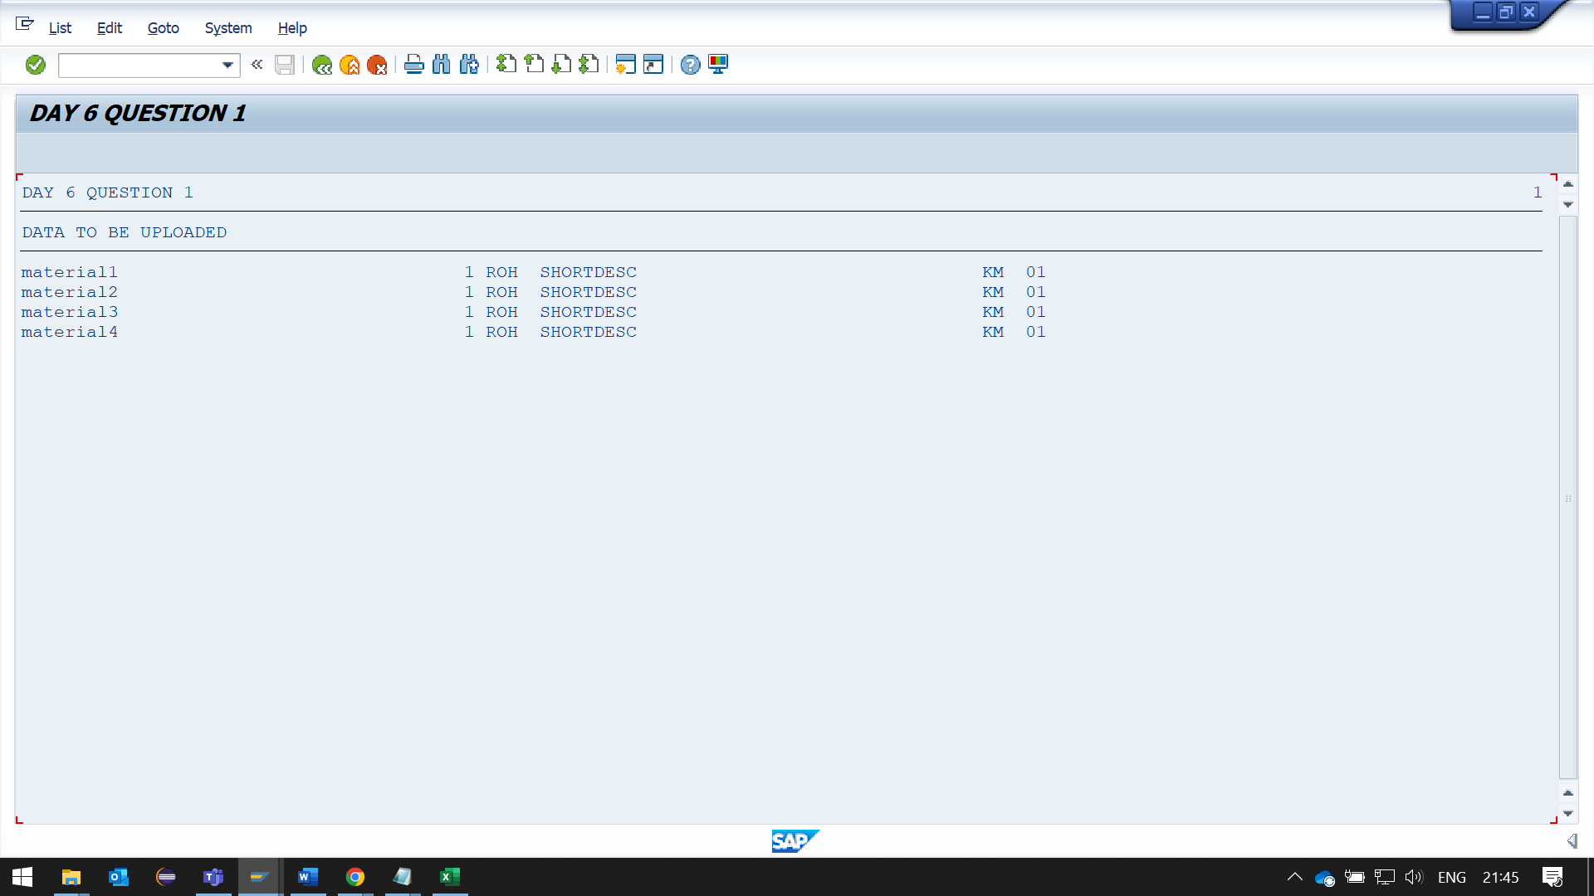

**UPLOADED FILE CAN BE FOUND AT /TMP FOLDER**

**GO TO AL11, THEN CLICK ON DIR_TEMP**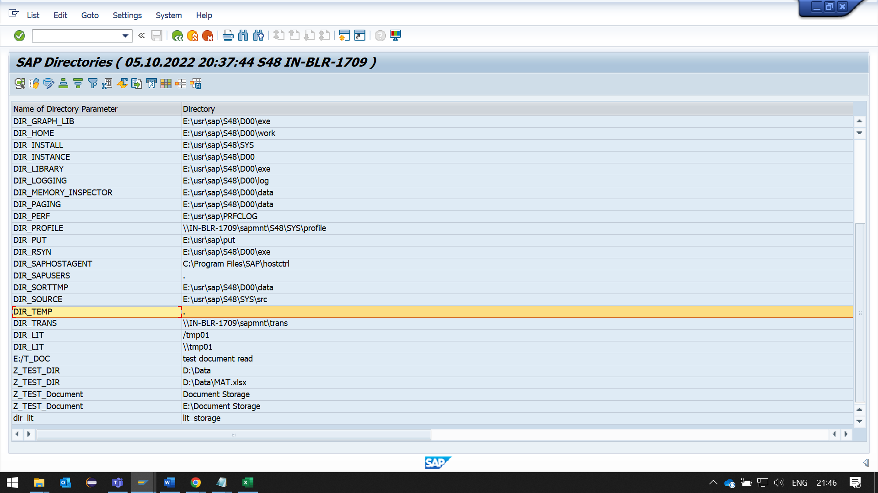

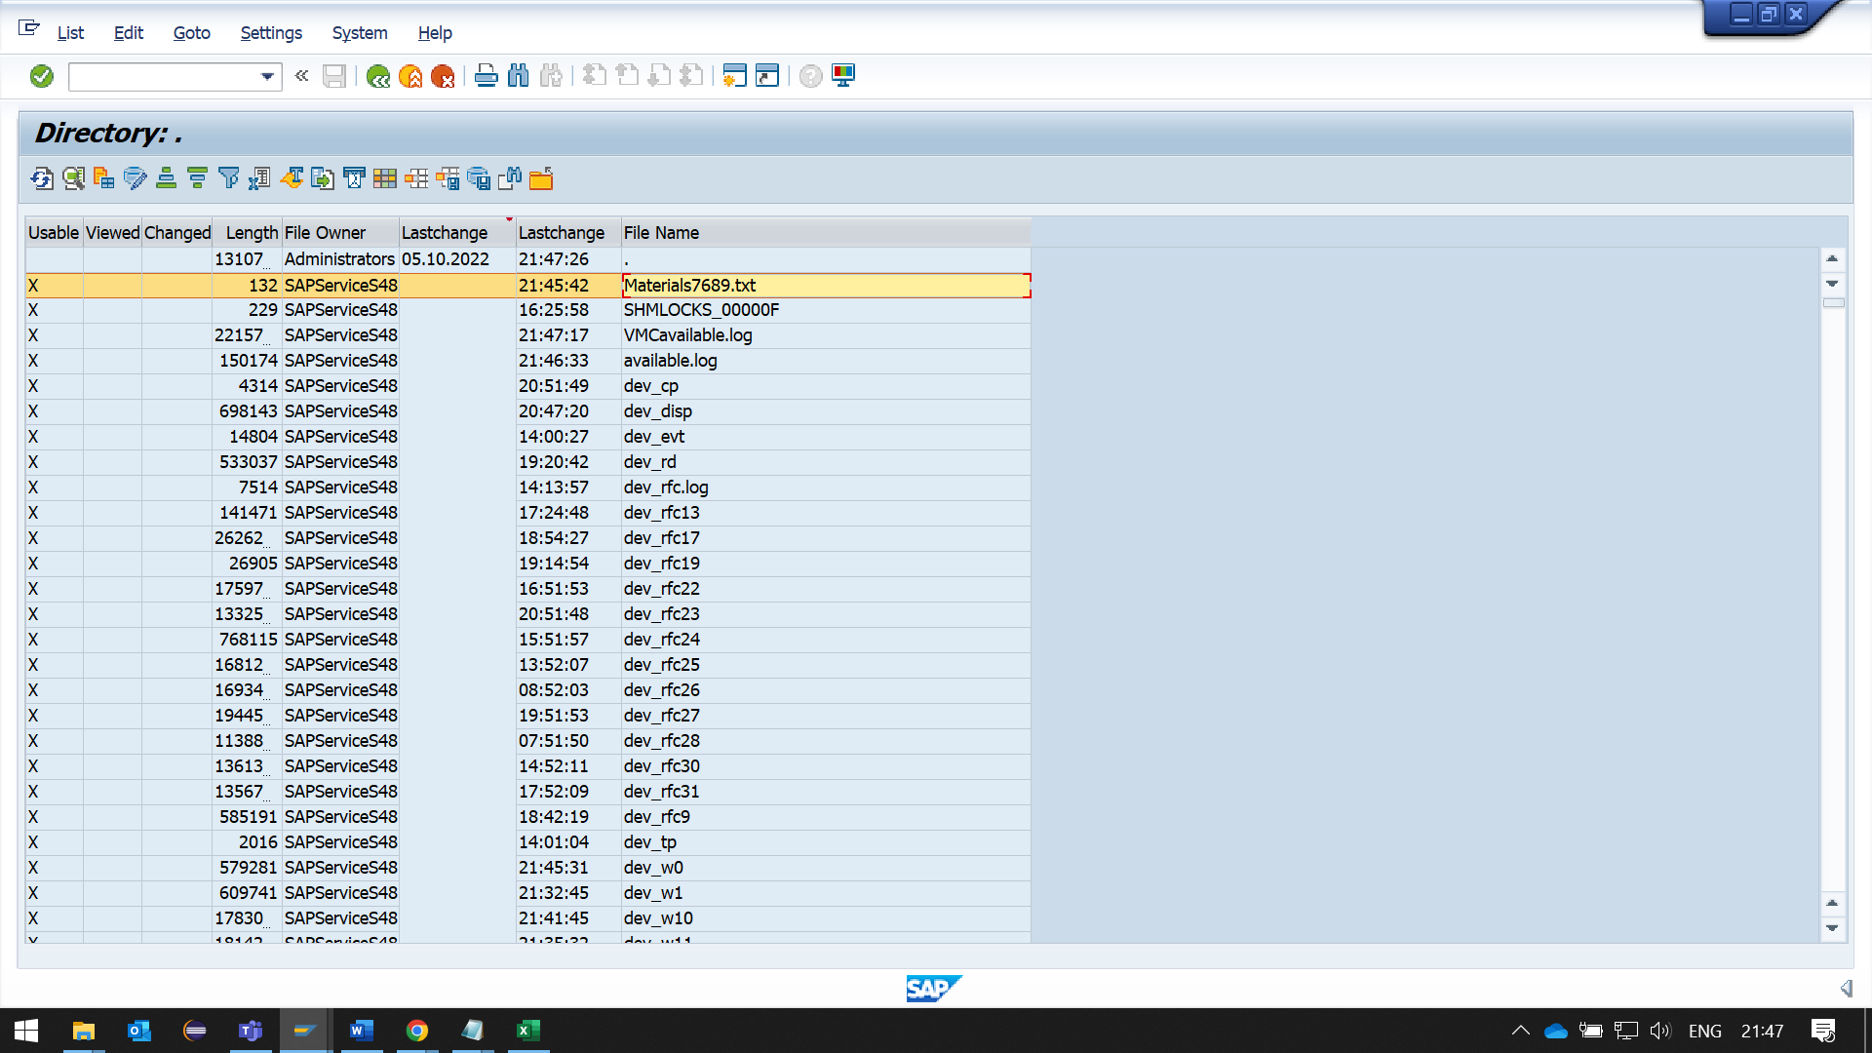

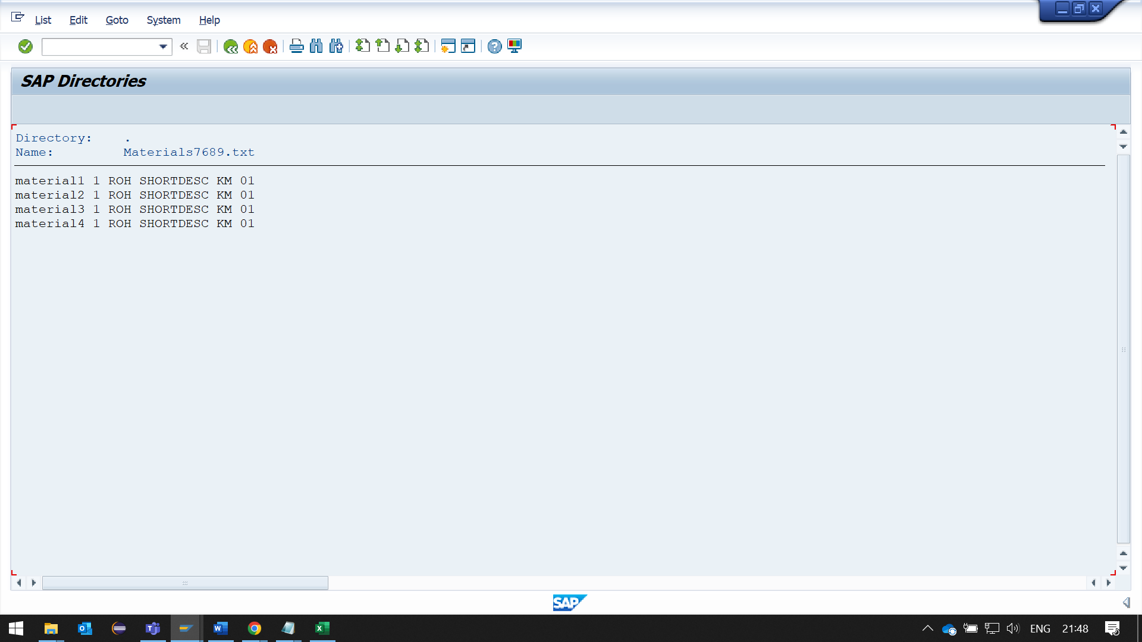

**2. Create a Program to download data from Application Server (AL11), Save it in a File in Presentation Server.**

**REPORT**

*\*&---------------------------------------------------------------------\**  
*\*& Report ZYNY_ABHAY_REPORT20*  
*\*&---------------------------------------------------------------------\**  
REPORT ZYNY_ABHAY_REPORT20.  
  
*\*----------------------------------------------------------------------\**  
*\*     Type Decalaration*  
*\*----------------------------------------------------------------------\**  
TYPES: BEGIN OF TY_MARA,  
         MATNR TYPE MATNR, *" Material Number*  
         MBRSH TYPE MBRSH, *" Industry sector*  
         MTART TYPE MTART, *" Material TYPE*  
         MAKTX TYPE MAKTX, *" MATERIAL DESC*  
         MEINS TYPE MEINS, *" Base Unit of Measure*  
         MATKL TYPE MATKL, *" Material Group*  
       END OF TY_MARA.  
  
*\*----------------------------------------------------------------------\**  
*\*     Data Decalaration*  
*\*----------------------------------------------------------------------\**  
DATA : it_mara TYPE  TABLE OF ty_mara,  
       wa_mara TYPE ty_mara,  
       lv_file TYPE string.  
  
DATA: gv_file   TYPE rlgrap-filename.  
  
gv_file = 'Materials7689.txt'.  
  
OPEN DATASET gv_file FOR INPUT  IN TEXT MODE ENCODING DEFAULT.  
*"INPUT : means u are going to read from the file*  
*"Load data from the file in Application server to internal table it_mara*  
DO .  
  READ DATASET gv_file INTO wa_mara.  
  IF sy-subrc  = 0.  
    APPEND wa_mara TO it_mara.  
    CLEAR wa_mara.  
  ELSE.  
    EXIT.  
  ENDIF.  
ENDDO.  
  
CLOSE DATASET gv_file.  
  
WRITE : / 'DATA DOWNLOADED'.  
ULINE.  
LOOP AT IT_MARA INTO WA_MARA.  
  WRITE : / WA_MARA-MATNR,  
            WA_MARA-MBRSH,  
            WA_MARA-MTART,  
            WA_MARA-MAKTX,  
            WA_MARA-MEINS,  
            WA_MARA-MATKL.  
ENDLOOP.  
  
*"Load  data from internal table it_mara to file p_file*  
CALL FUNCTION 'GUI_DOWNLOAD'  
  EXPORTING  
    filename              = 'C:\Users\abhbhagw\OneDrive - Capgemini\Desktop\Data_downloaded.txt'  
    filetype              = 'ASC'  
    APPEND                = 'X'  
    write_field_separator = 'X'  
  TABLES  
    data_tab              = it_mara.  
IF sy-subrc = 0.  
  WRITE : 'The file is downloaded from Application server to your Desktop.'.  
ENDIF.

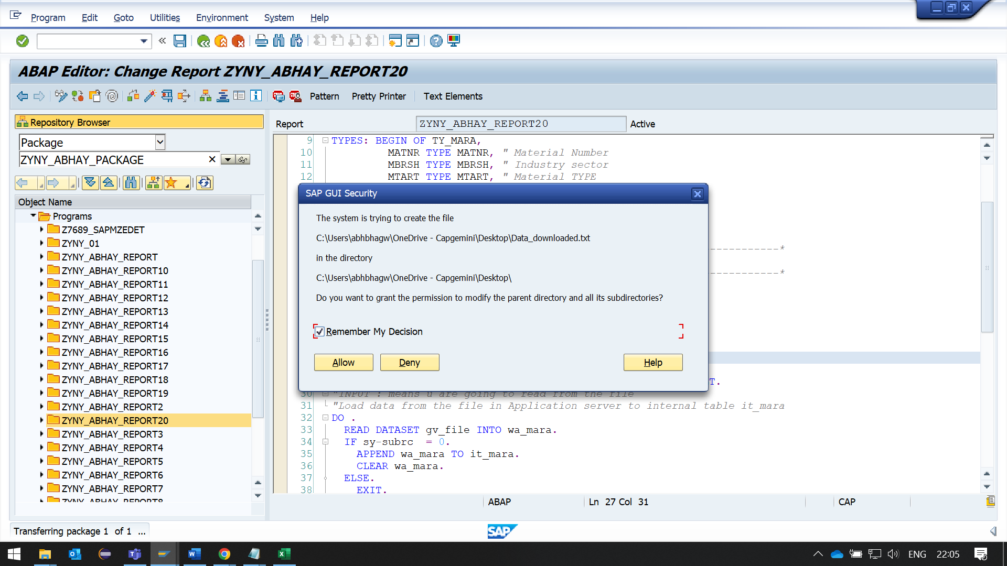

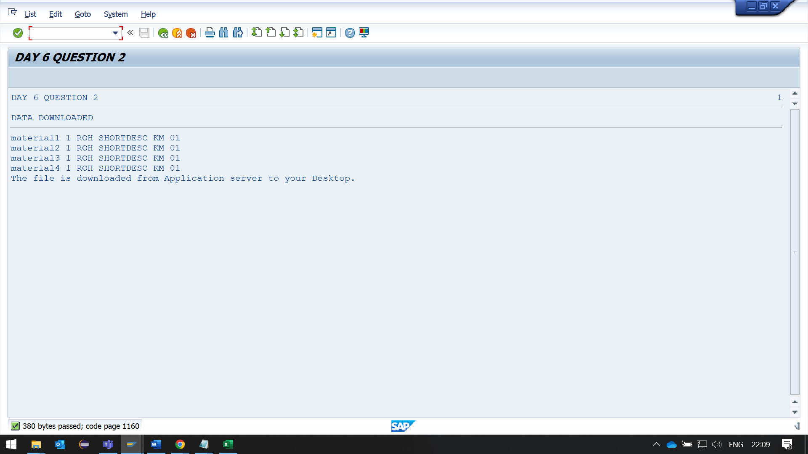

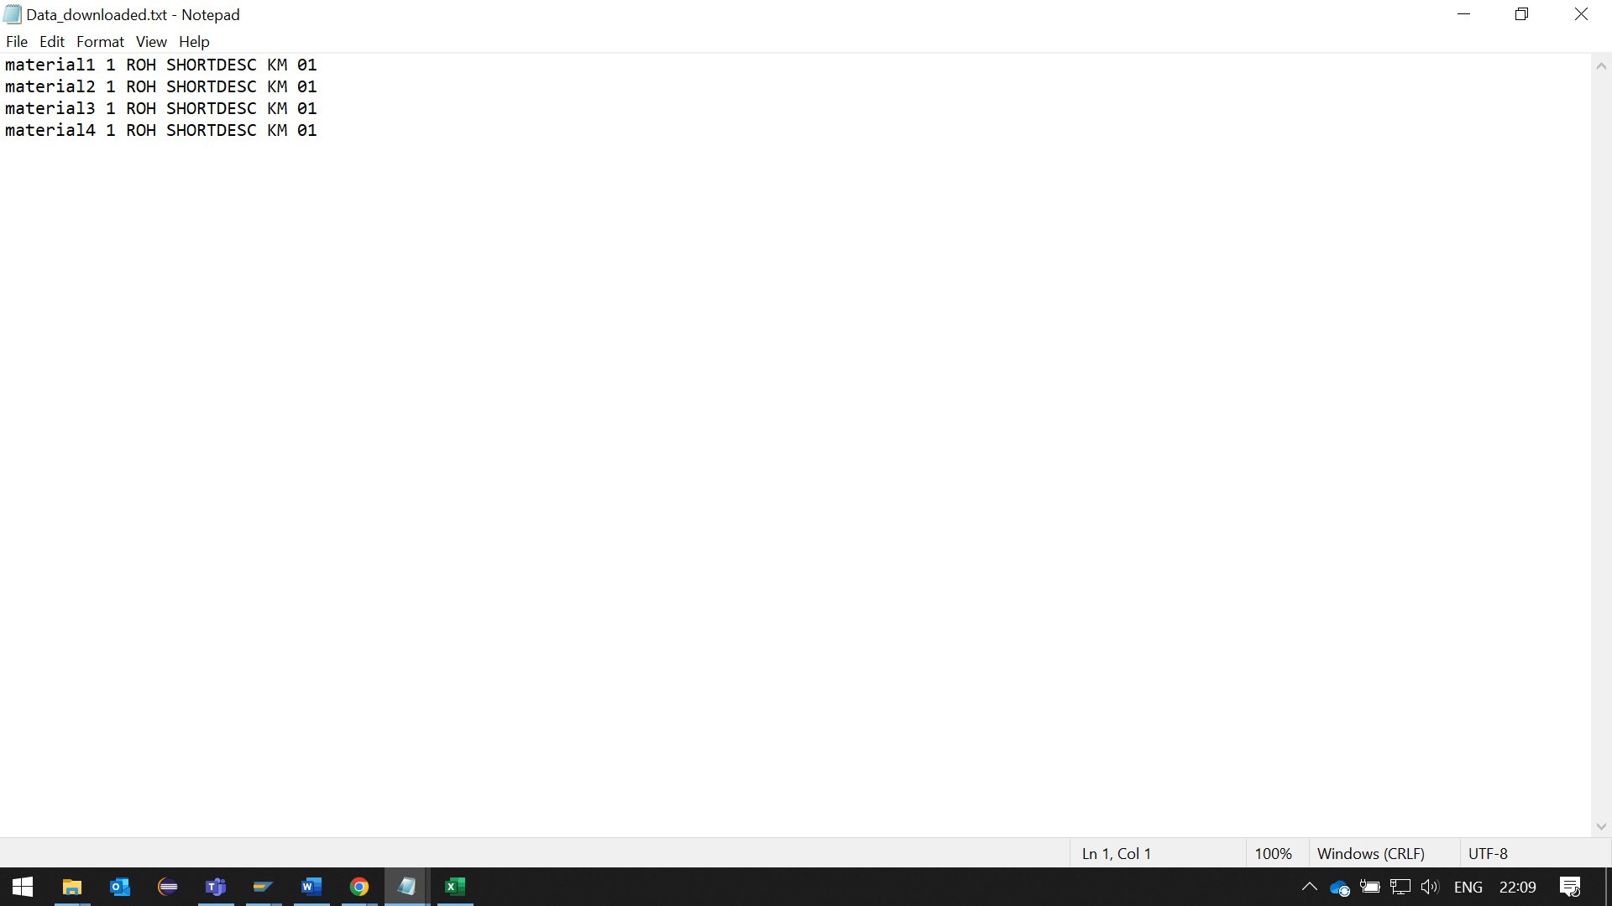

**3. Create a program to Upload the Material data from Excel Sheet & Use a Bapi to update Material Details**

**(Test the BAPI using test sequence & Use this BAPI to update the Material Data).**

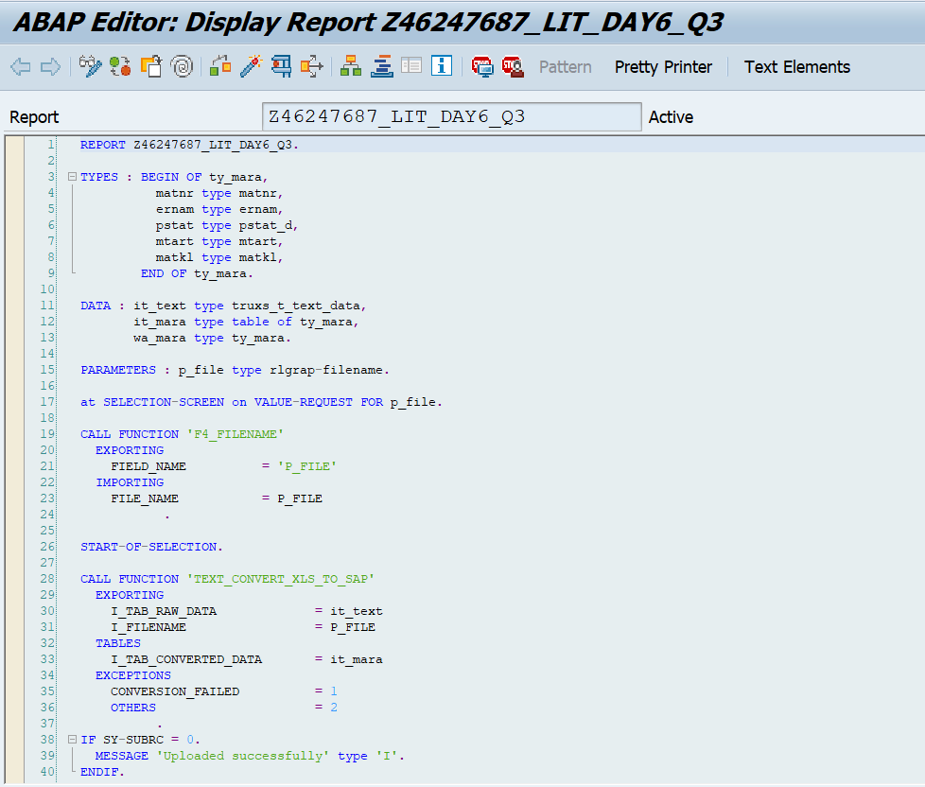

Output:

